THE GRANITE CHIPS

Quincy Quarry & Granite
Workers Museum
P.O. Box 690724
Quincy, MA 02269

Window Display Change at Granite Trust Building
The Quarry Museum will be changing the window display of the first quarries in Quincy, the Native Americans at the Granite Trust Building located in Quincy Center. The change is scheduled for the month of June. The upcoming months will be your last chance to view the display that features artifacts and interpretive information on the Native American quarries.

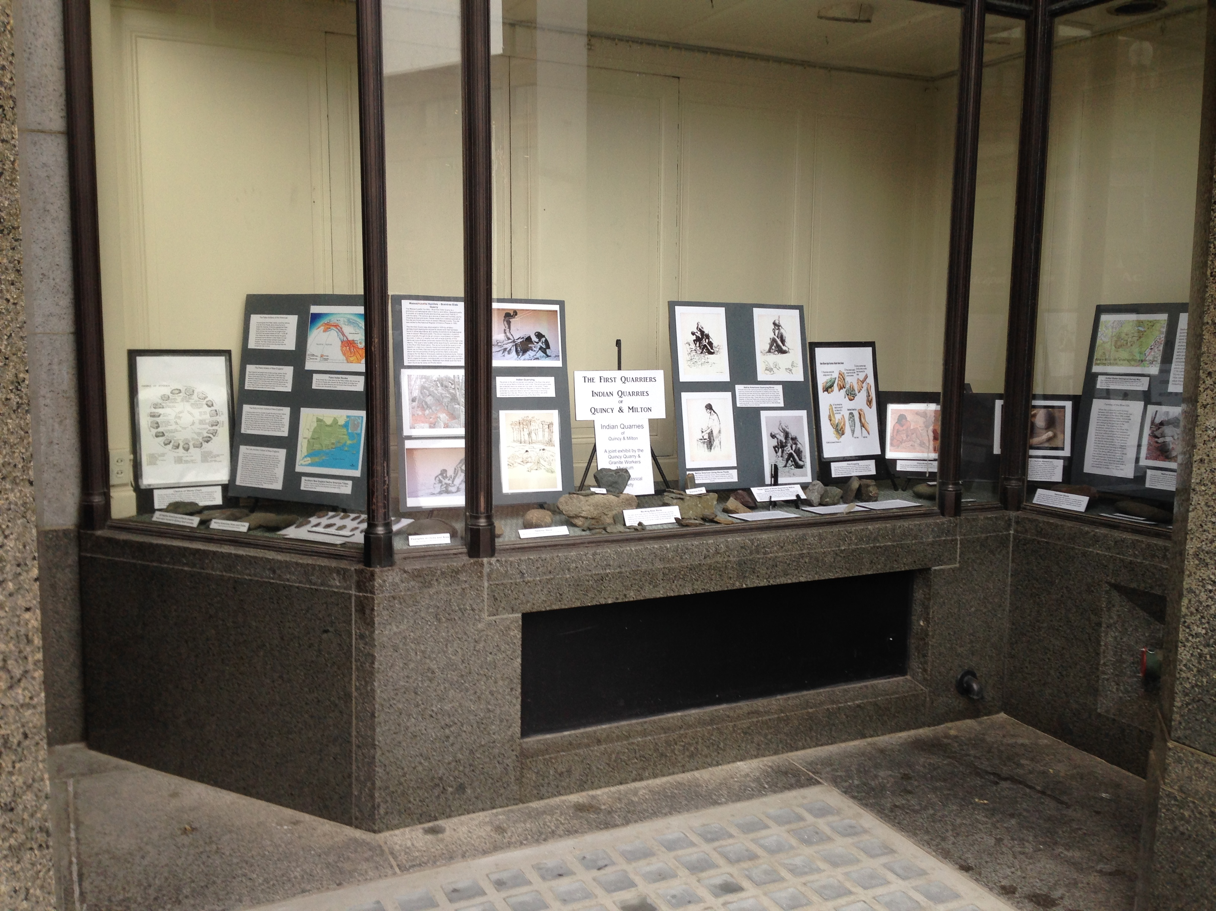
THE Spring 2020
GRANITE CHIPS
Quincy Quarry and Granite Workers Museum, P.O. Box 690724,. 02269
quincyquarrymuseum@verizon.net 617-472-1322

From the President
There is a glimmer of hope that the corona virus is behind us and we can get back to somewhat of a normalcy. As the economy recovers we look forward to establishing a larger home for the museum. As we move forward, day by day, there is great enthusiasm from the public on the prospect of a permanent museum to preserve and display the story of our great granite history not only of Quincy but the granite history of the surrounding communities. As more information is acquired from our members and non- members, we are led out of Quincy to our neighboring towns which are part of this great history. The strength of any organization is in its members that is evident in the support we have received from the community and our members. Our goal for this year is to increase our base membership and continue our building fund effort to establish a home for the museum. In the interim we want to thank our members for helping us to establish our Mini Museum at the Lyons Turning Mill to display many of the artifacts we have acquired to date. As for programs, the Museum’s plan for the upcoming year will include a geology presentation on Quincy granite, a stone splitting demonstration which will be again a hands-on experience, a stone finishing presentation and tours of the Museum and the Lyons Turning Mill. We're also planning quarry walks which will include the inclined Plane Railway and the Granite Railway the first commercial railroad in America. To all our members I would like to thank you on behalf of the officers and trustees for your continued support for renewing your membership and the new members who have joined in support of preserving the granite industry history.

Museum Stone Yard
The Museum’s stone yard has added several newly acquired artifacts for the demonstration of the working of stone. The newly acquired artifacts include a tripod frame with a 1 ton chain fall, sawhorses, banker frames, a skid platform with pipe rollers for moving granite and a rebuilt four-wheel cart. All artifacts came from the Carrigg stone shed that sadly is scheduled for demolition.

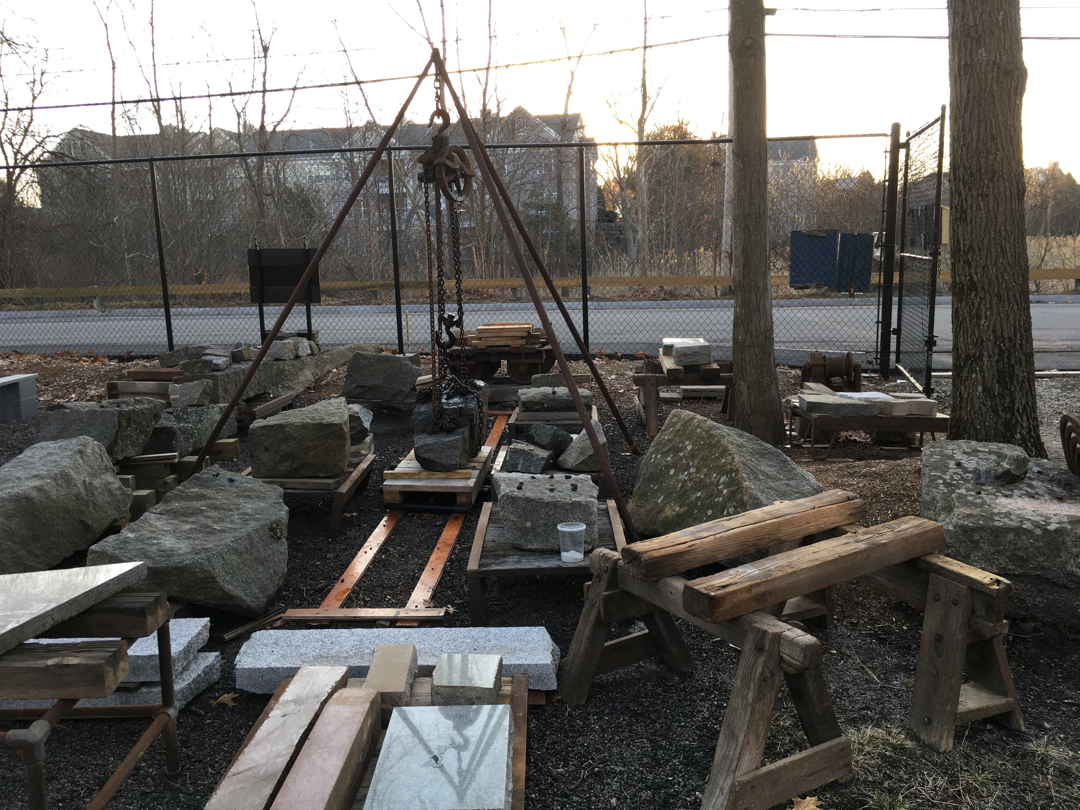

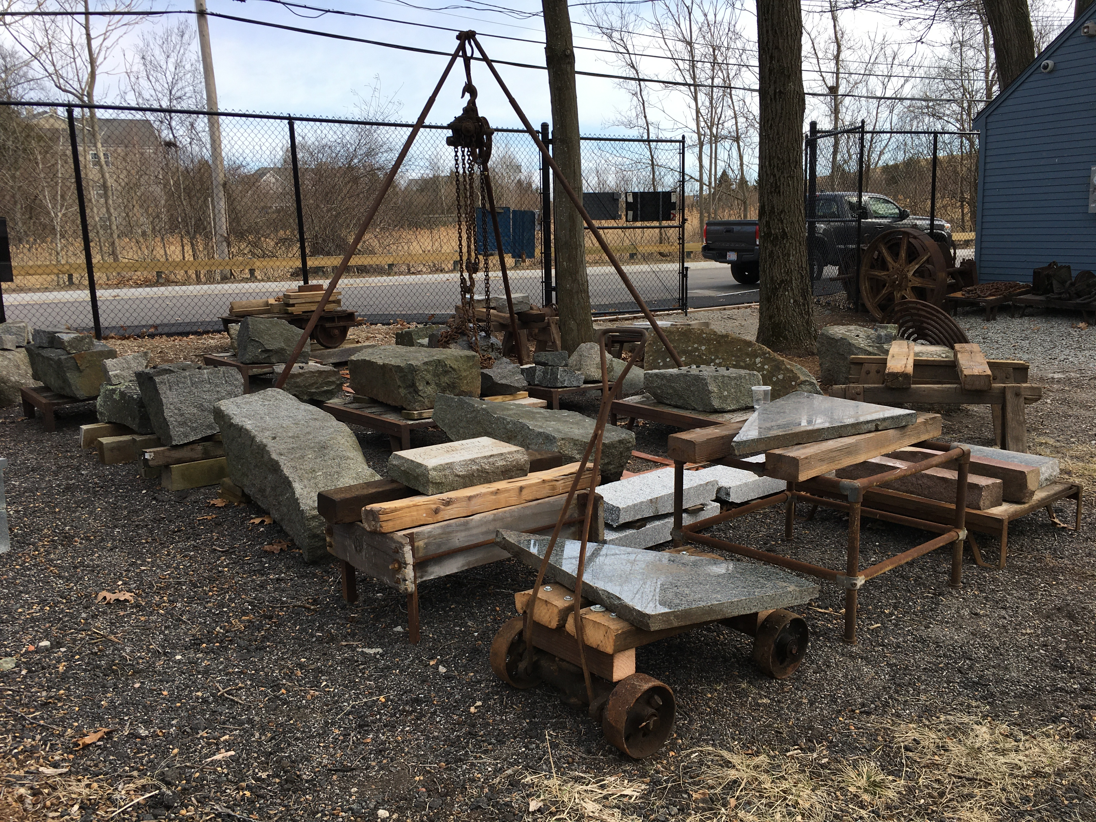
Artifacts Donated by James Larkin
Jim Larkin a member of the Museum has donated two interesting artifacts. The first is a monument sales catalog dated from 1886 with pictures of monuments that can be produced for buyers of stone products. The journal belonged to his grandfather Richard Larkin (1857 – 1898). Richard Larkin’s father, Daniel Larkin, immigrated to America from Balllarkin, Freshford, Co Kilkenny, Ireland in 1854 and worked in the quarries of Quincy. His son, Richard, followed his father in the granite industry and worked in several quarries in Quincy as a stone cutter. He went on to become head lead salesman for the stone and monument sales business of the Swingle's family business. The Museum has very little original written documents which makes this donation very valuable to the Museum. The second artifact which is not granite but is of interest to the Museum is a chair; but not so much the chair, but what the back of the chair represents, an early Victorian wooden grave marker. The chair has been in the family going back to Jim's grandfather, Richard Larkin. On investigation of the chair, the present back was attached to the original chair. Since Jim's grandfathers were both in the business of grave markers, that may have been an artifact that was saved as a historical relic by one of them and at some point attached to the chair. The back of the chair shows signs that it was much longer and was cut off to attach as a back to the chair. The Museum is interested in saving all information and artifacts related to how the stone and monument industry evolved. Photo Right.

Welcome New Members
Thank you for joining the Quincy Quarry & Granite Workers Museum and supporting our effort to preserve the granite history of Quincy and surrounding communities

Kris Kamborian Courtney Swimm
Joanne Kelly The Dolben Company Inc.
Harriet Goodwin
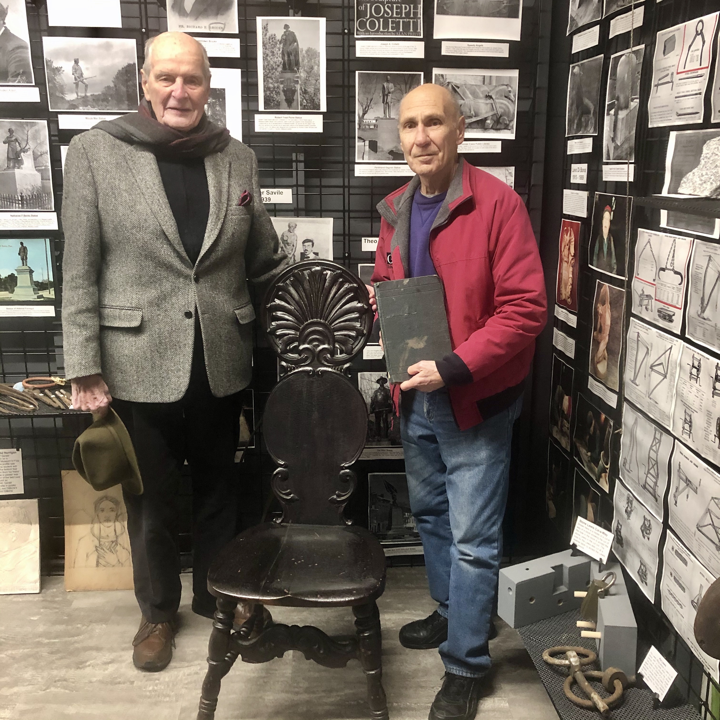
Photo L to R: James Larkin and Al Bina with chair
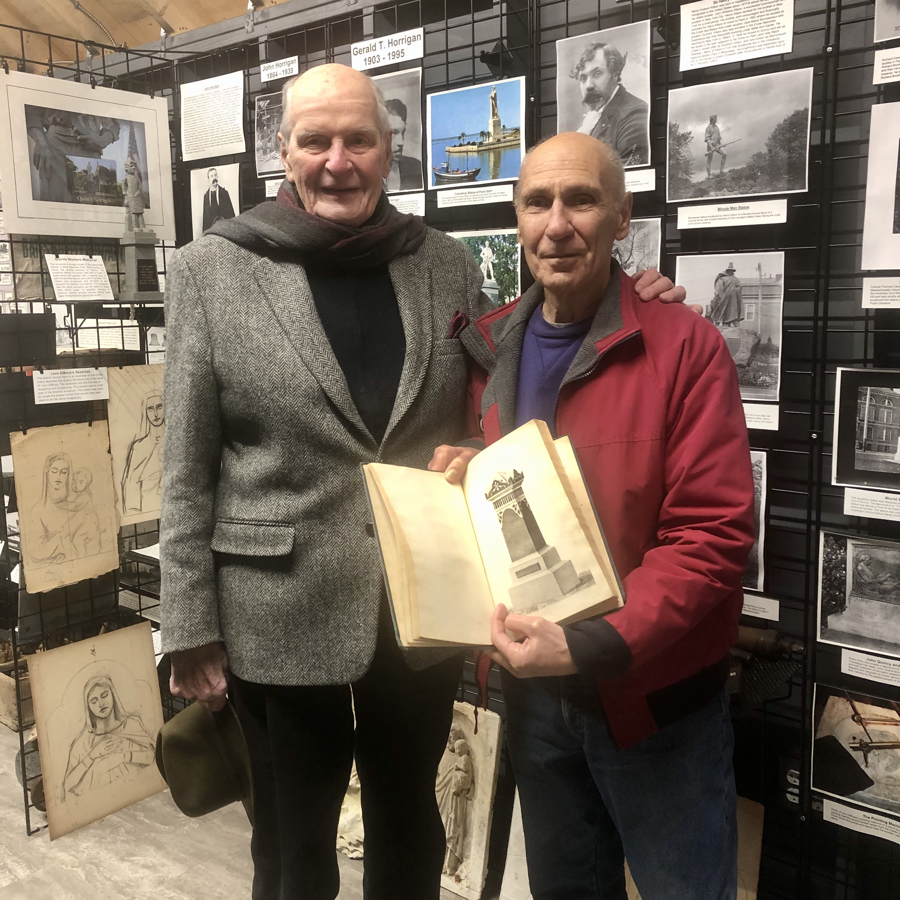
Photo L to R: James Larkin and Al Bina holding the sales catalog journal

Please support our business members that support us.
Granite City Electric
Granite Links Marina Bay
Neponset Valley Survey
Quincy Credit Union
Quincy Memorials Inc.
Galvin Construction
Bates Brothers Granite Co.
A. Monti Granite Co.
The Dolben Company Inc.
Thomas Carrigg Stone Shed Artifacts
The Thomas Carrigg & Sons stone shed located at 165 Brook Road, South Quincy has been purchased by Mark Bogan of Bogan Tree Service, Quincy. The Carrigg stone shed is the last vintage of over 125 stone sheds that were scattered throughout Quincy at the turn-of-the-century. The Thomas Carrigg & Sons stone shed was purchased by Thomas Carrigg in the late 1800s and continued operation by the family until it ceased production operations in Quincy as an active stone shed around 1995. The Carrigg family continues in the monument business today with a showroom yard in West Roxbury. The stone shed on Brook Road was like going into a Museum with tools and equipment that went back to the 1800s. When Mark Bogan purchased the building, Museum president Al Bina approached Bogan for access to the stone shed and he was granted access. It was determined that there were many valuable historical artifacts of the granite industry that the Museum was interested in acquiring to display at the Museum. Mark Bogan the owner of the property gave the Museum permission to acquire any artifact that they could use at the Museum for display or use in demonstrations. President Al Bina and Museum historian Tom Bonomi spent days acquiring a trove of artifacts from the stone shed location. Many of the artifacts will be on display at the Museum and in the Museum’s out side stone yard display. One of the prized artifacts was the original sign on the shed building that displayed the name “Thomas Carrigg & Sons Monuments” which will be displayed at the Museum. The museum wants to thank Mark Bogan for his interest in saving part of Quincy's rich granite history. Unfortunately the building will be coming down but many historical artifacts were saved for future generations viewing at the Museum. Pictured at the right are just a portion of artifacts that were acquired. Many of the artifacts can be viewed on the web site quincyquarrymuseum.org
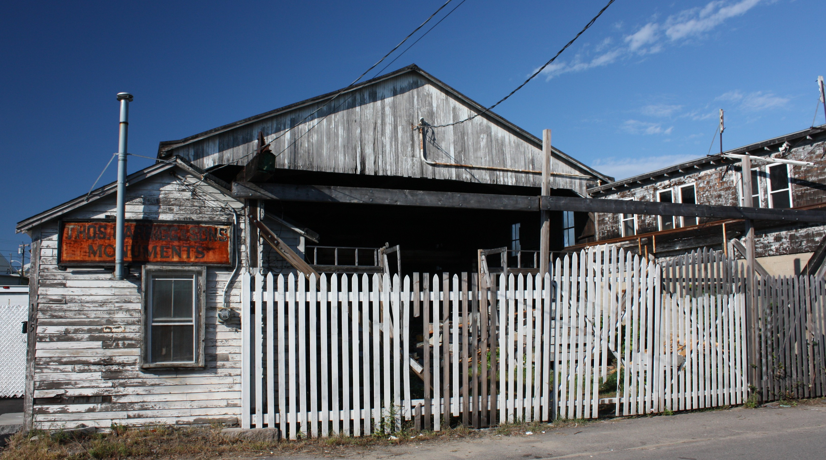
Carrigg office and stone yard and shed
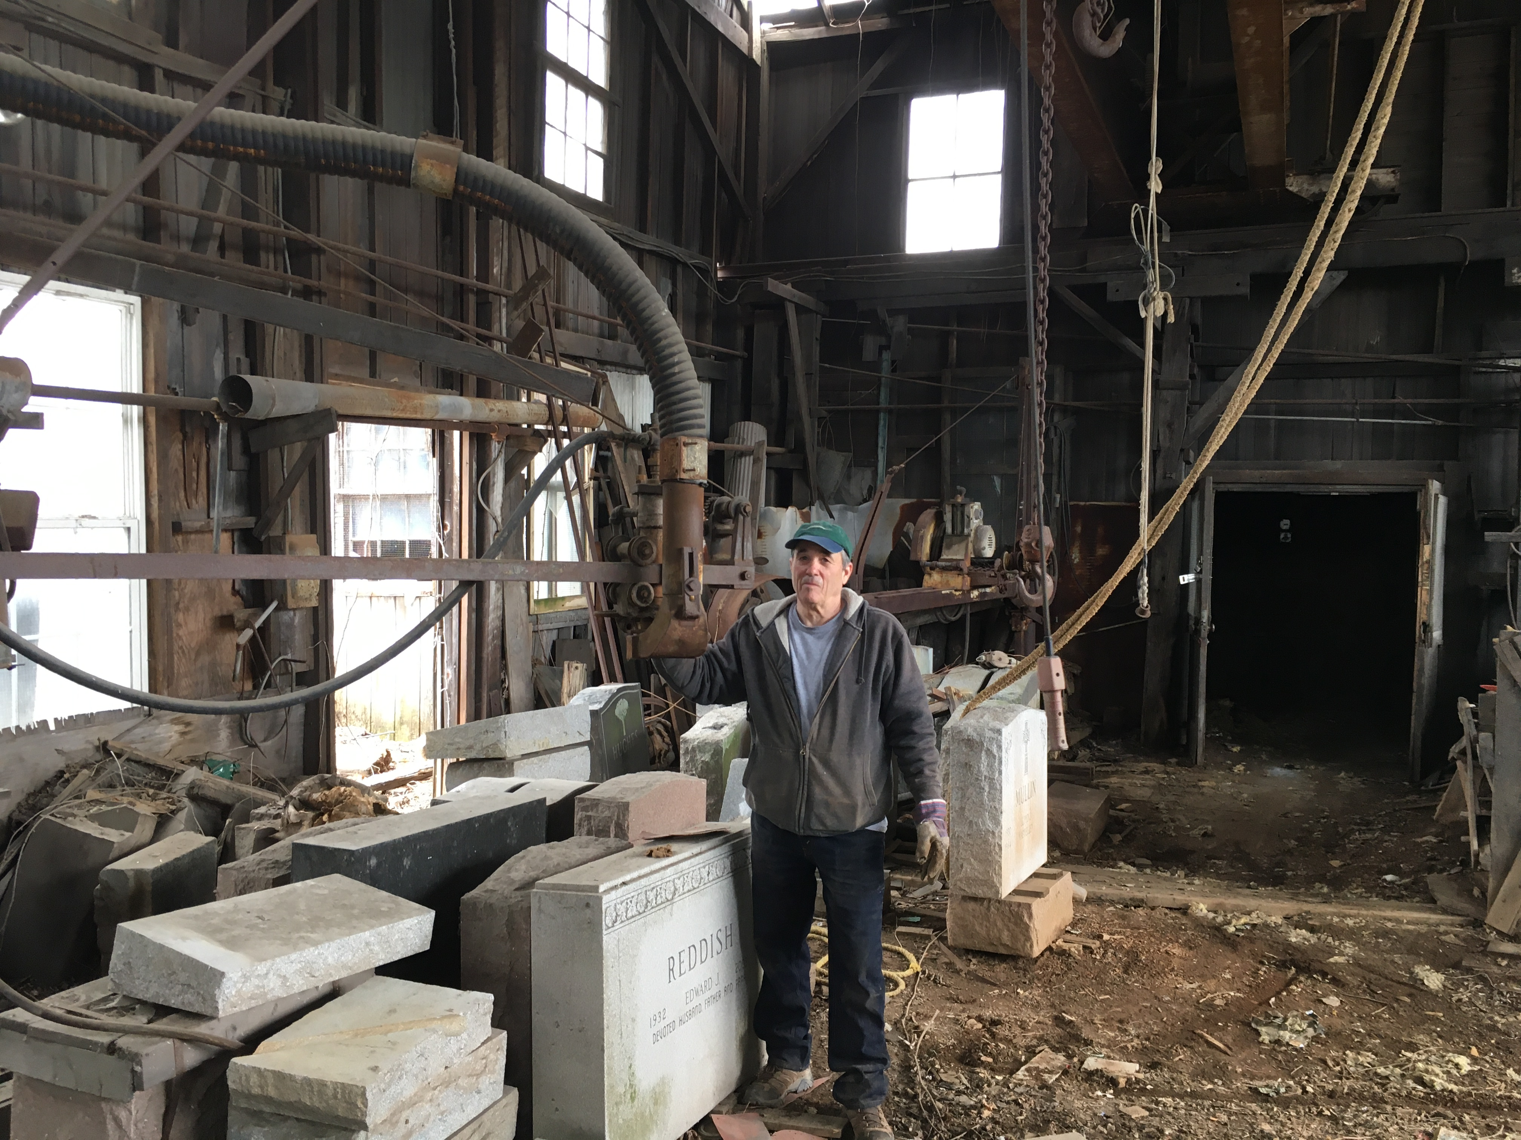
Tom Bonomi with a pneumatic surfacer
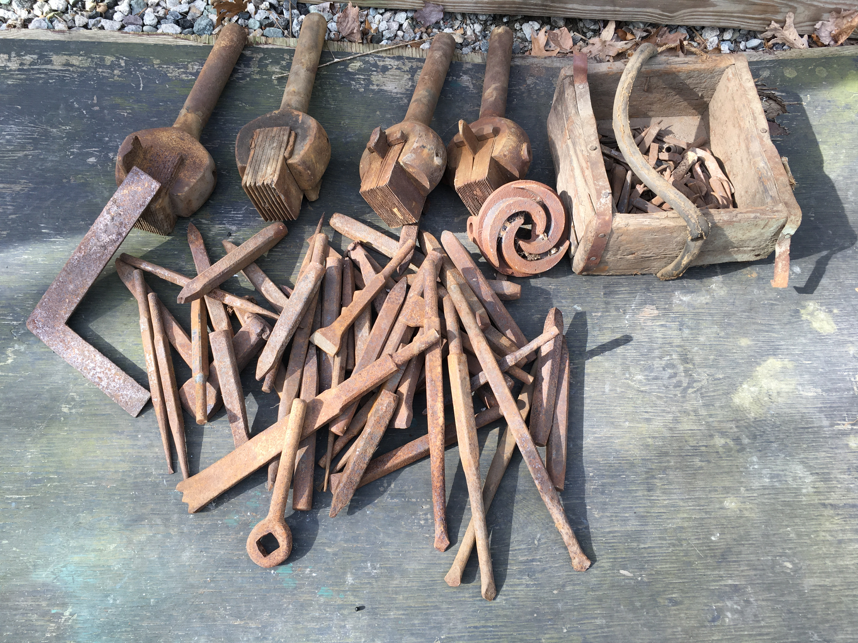
Sample of over 100 tools acquired
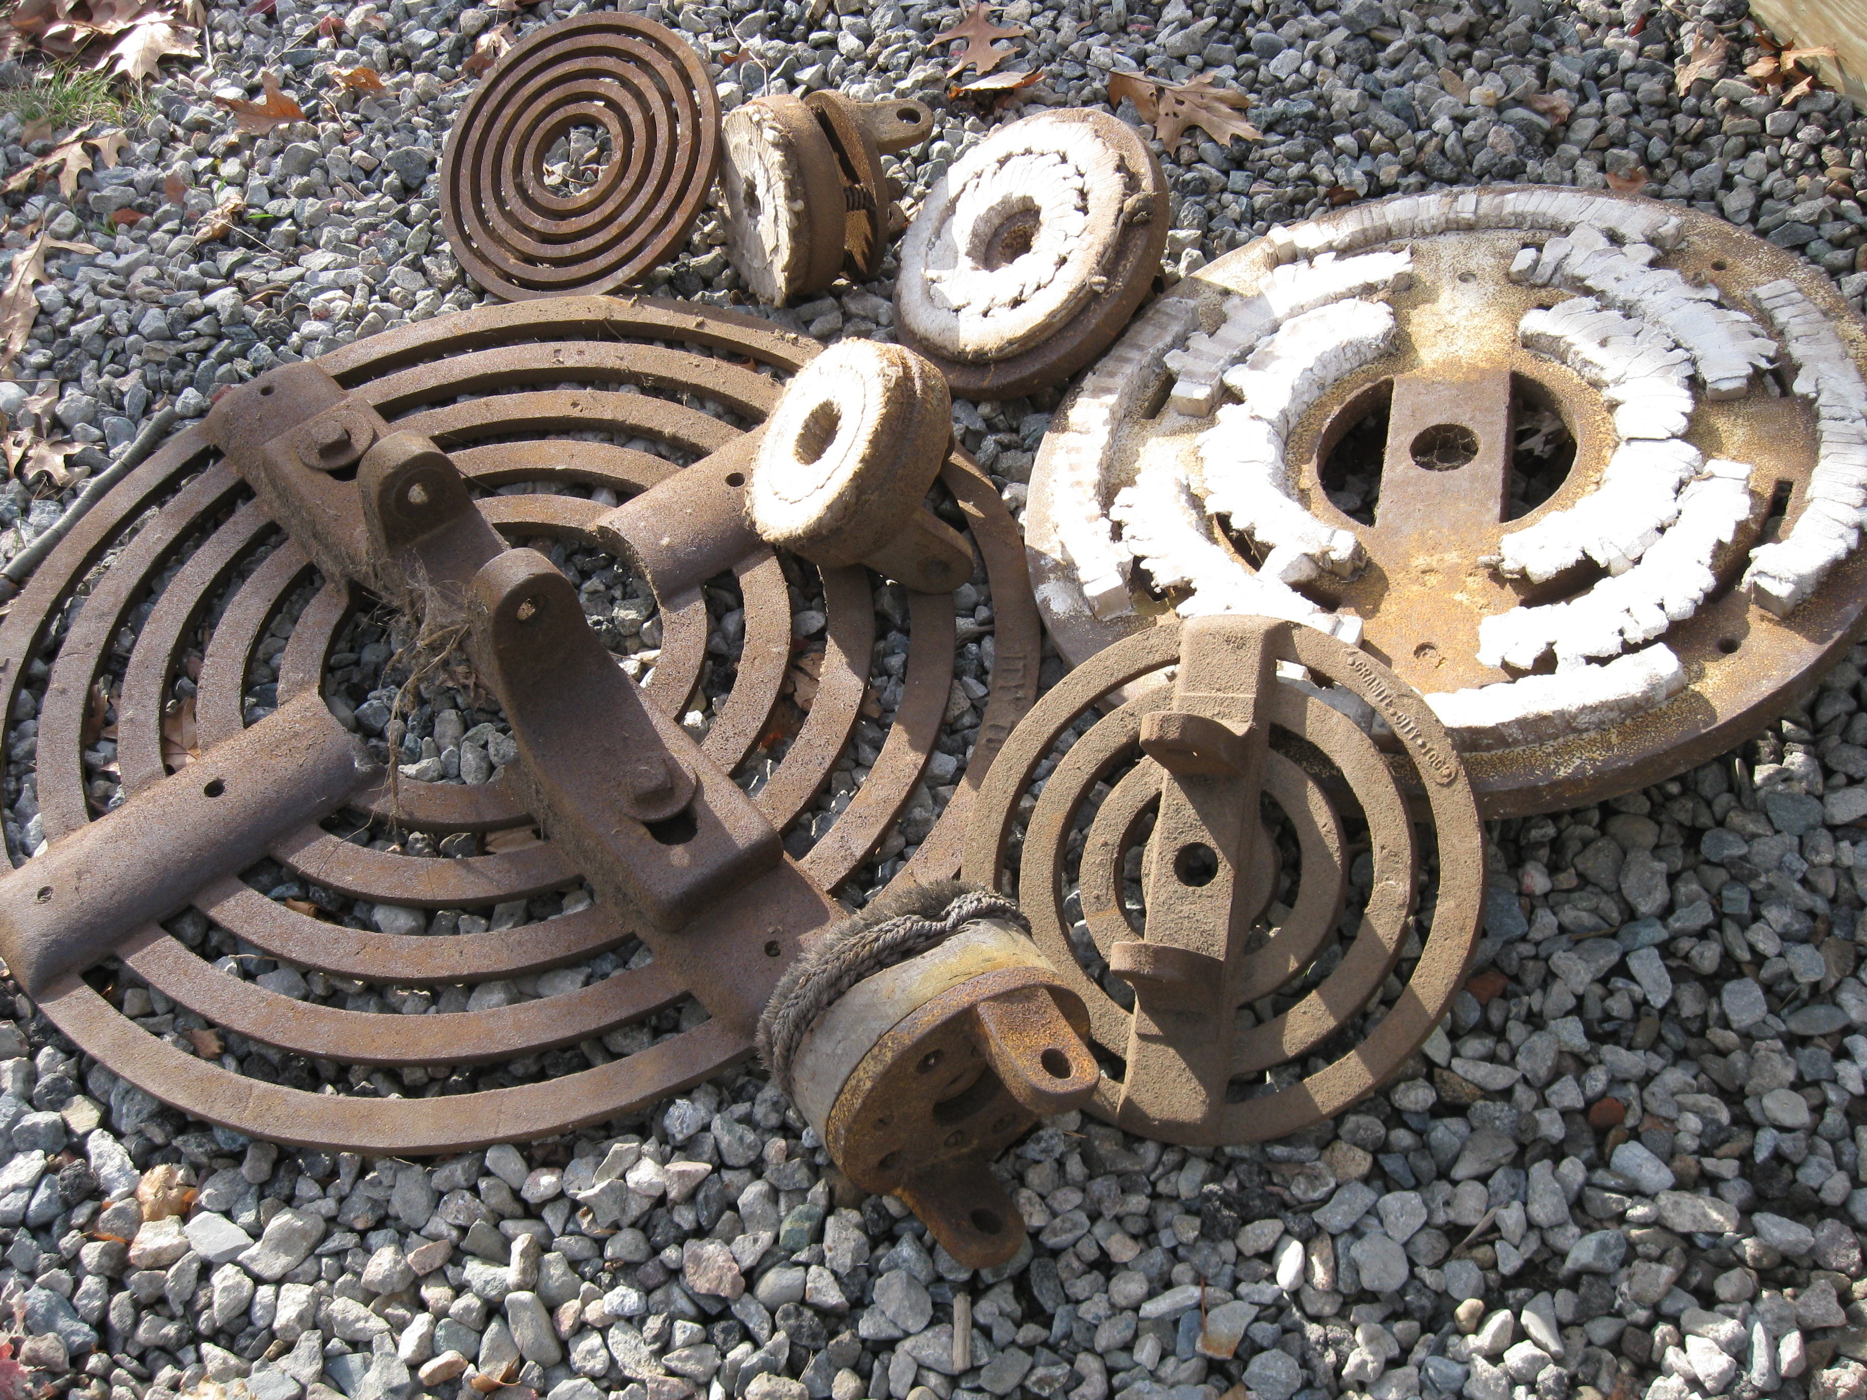
Sample of over 50 polishing disc acquired

Thomas Carrigg Stone Shed Artifacts

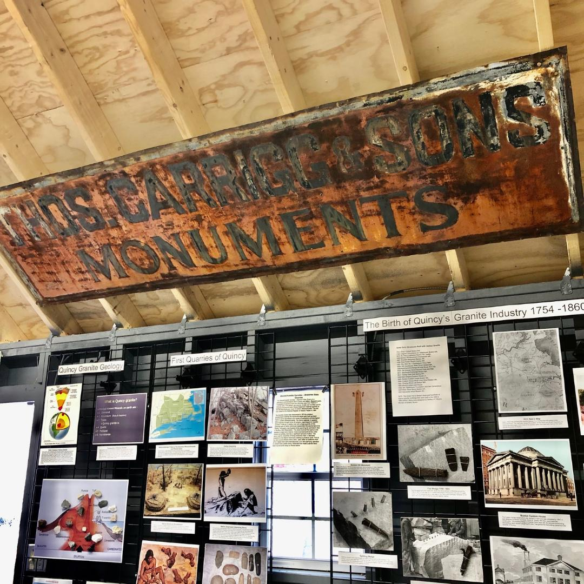
Thomas Carrigg & Sons sign in Museum

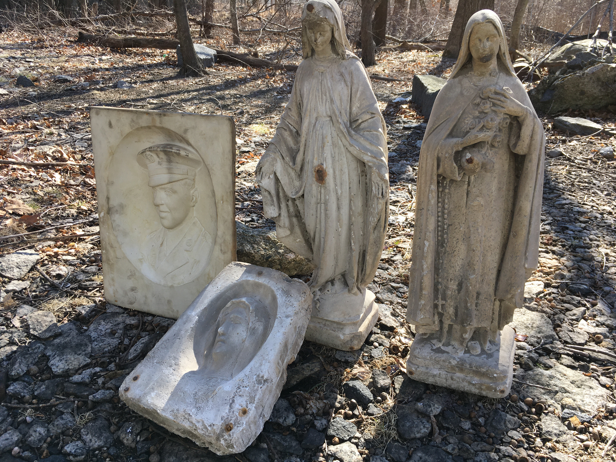
Models with pointing machine points

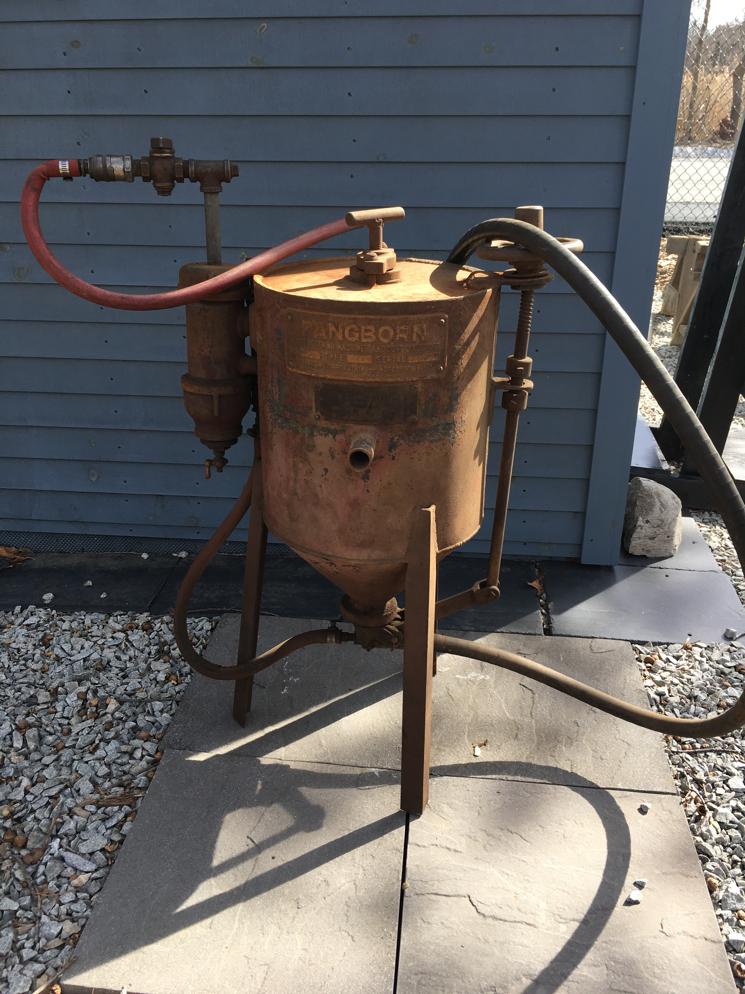
Sand Blasting Unit
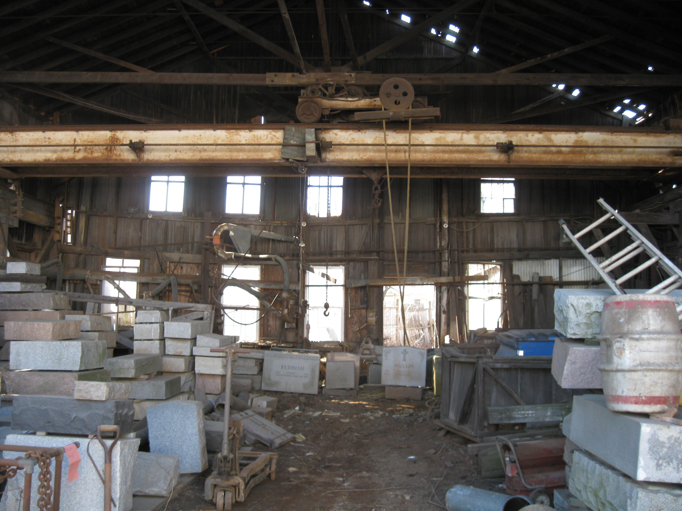
Interior of stone shed soon to be gone

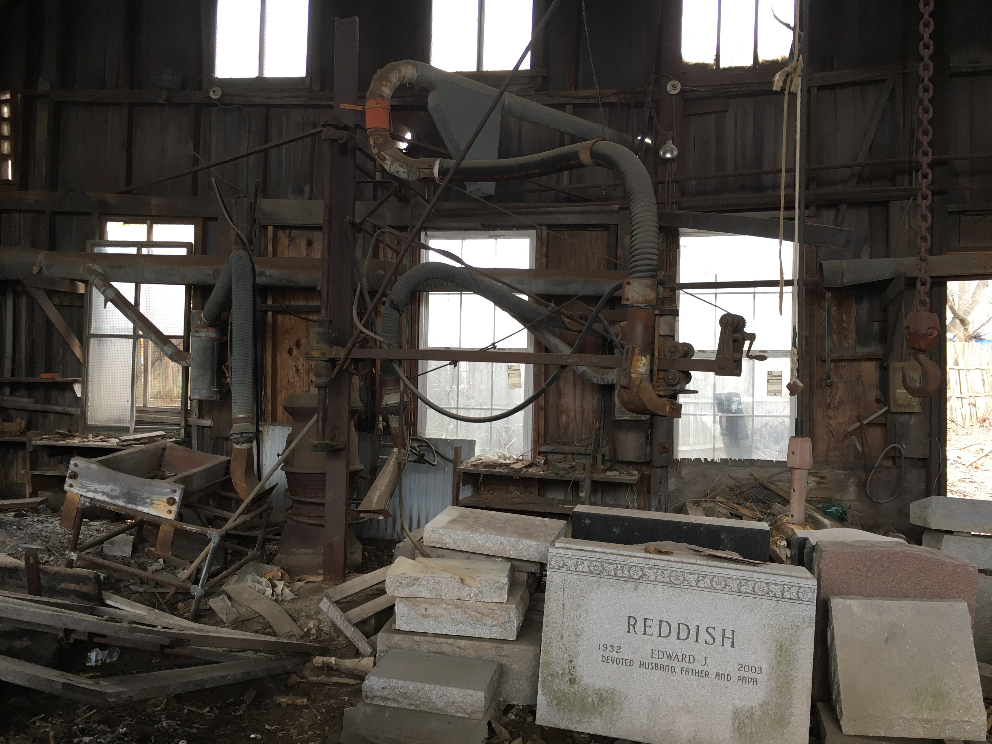
Surfacing machine with dust collector

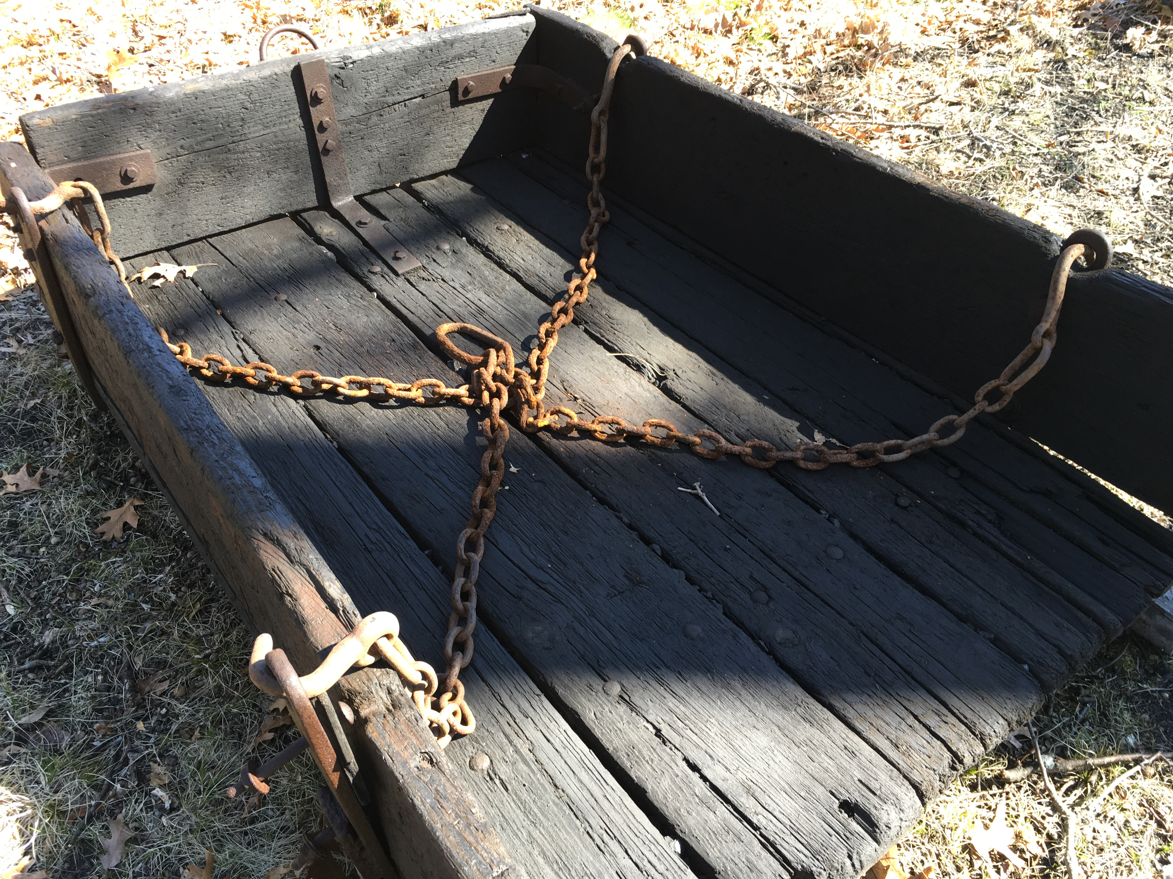

Grout Boat used to dump stone chips
Quincy Quarry & Granite Workers Museum
2020 Schedule

March
Museum Open
March 7th 10 am to 2pm
March 8th 10 am to 2 pm

April
Museum Open
April 4th 10 am to 2 pm
April 5th 10 am to 2 pm

May
Museum Open
May 2nd 10 am to 2 pm
May 3nd 10 am to 2 pm

June
Museum Open
June 6th 10 am to 2 pm
June 7th 10 am to 2 pm
Granite Railway &
Bunker Hill Quarry Walk
June 13th 10 am to 12
Museum open after walk until 2 pm

July
Museum Open
July 4th 10 am to 2 pm
July 5th 10 am to 2 pm
Inclined Plane Railway Tour
July 18th !0 am to 11:30 am
Museum open after tour until 2 pm

August
Museum Open
August 1st 10 am to 2 pm
August 2nd 10 am to 2pm
Quincy Homestead open house. Granite industry display by Quarry Museum
August 15th 11 am to 3 pm

September
Museum Open
September 5th 10 am to 2 pm
September 6th 10 am to 2 pm

October
Museum Open
October 3rd 10 am to 2 pm
October 4th 10 am to 2 pm
Archaeology Month open house
Lyons Turning Mill and Museum
October 17th 10 am to 2 pm

November
Museum Open
November 7th 10 am to 2 pm
November 8th 10 am to 2 pm

Check Museum web site quincyquarrymuseum.org
for Geology, Stone Splitting, Stone Finishing and other activities when dates and times are determined.

Please note all walks and tours are over rocky terrain. Any questions call the Museum at 617-472-1322.

Private tours are available upon request. Call the Museum and leave name and contact number.

Directions
Starting at the intersection of Willard and Copeland St., West Quincy, at Curry Hardware proceed under the expressway and stay to the right to stop sign and blinking red light. Use caution crossing expressway ramp on to Ricciuti Drive. UPS store on right. Proceed up Ricciuti Drive to the end and turn right onto Quarry Hills Drive. Museum one hundred yards on the left.

All events and museum are free.
Donations are appreciated.

